1. **Agenda:** We will see what is **Exchange and Queue in RabbitMQ Message Broker**.
2. **Real Life Example**: Say, you went to one electronics store and you want to buy the mobile. Now the shop is big and there are different departments one for mobile, one for TV and another one for AC.  
   So, basically, you don’t know where the mobile department is there inside the shop.   
   Let’s say there is a person X coming to you and says to you “How may I help you sir” and you say “I want to purchase a mobile”. The X person would redirect you to the mobile department or a mobile counter by giving you directions.  
   So, basically you will be routed to mobile department. There will be one person or multiple persons. Now they will assist you so that you can purchase a mobile.
3. **L**et’s understand this real life example with perspective of JMS.
4. Here you’re the message this is to be routed from producer to consumer using exchange and queue.  
   The person asking “How may I help you” is the Exchange that would route the message.  
   Here mobile department is Queue.  
   There may be many queues such as one for sending email confirmation related to order and second queue for setting up the shipping detail with 3rd party courier.
5. 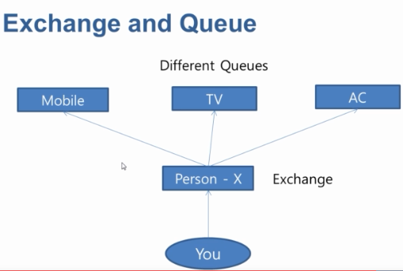
6. As it is the case that you know the mobile department and going there directly. The same can be possible in JMS. Then why do we need exchange?
7. Exchange is needed when we want to apply some conditions and based on conditions, we want to route the message.
8. Basically, there are 4 kinds of exchanges.
   1. Direct
   2. Fanout
   3. Header
   4. Topic.

**NOTE**: Each one type has got its special purpose.